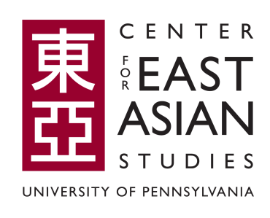 | Center for East Asian Studies  Faculty Research Grants  2024-2025
In the 2024-2025 Academic Year, the Center for East Asian Studies will award grants, in an amount of up to $3,000, for faculty research travel related to East Asia. All faculty members who are teaching or researching on East Asia are eligible to apply. The grant can be used for university-approved travel (transportation, hotels, per diem), research equipment, and other related expenses.
Awards will be made on the basis of the competitively established merit of the proposals. Priority will be given to standing faculty. Awards will be decided by the CEAS Executive Committee.
In order to be considered for a grant, please submit a completed application form. Grant recipients will be reimbursed upon submitting all relevant receipts after completing the travel. Please e-mail a completed application form by 5 pm, Friday, October 25, to David Dettmann (dettmann@upenn.edu). Award notifications will be e-mailed in November. Following the research trip, a brief one-page report describing the activity and benefit gained for teaching about East Asia at Penn must be submitted to CEAS.
A. APPLICANT INFORMATION:

Name: Position:
Department:
School:
Campus address:
E-mail: Telephone:

B. PROPOSED RESEARCH PROJECT:
Be sure to be as specific as possible with your proposal (i.e. what archives will be used, who or what will be surveyed, what exactly will be done?). Archival research proposals should also indicate whether archives have been contacted for permission.
Title:
Date/period of the proposed project:
Outcome of the project: will there be a new course or publication resulting from the research?

What is it, and when is it expected to occur?

Proposal abstract (150 words maximum):

C. BUDGET:
(Provide a concrete budget using specific numbers from researched quotes and reasonable travel fares)
Item | Business Justification | Date(s) | Cost
TOTAL

D. OTHER FUNDING SOURCES, IF ANY, AND AMOUNT:

